TITLE
Washing Machine With Arduino Uno And IoT Integration
AUTHORS
Ali Ridha Bin Muhammad Aminudin, Siti Norathirah Binti Razally, Nur Alya Sakinah Binti Mohd Mokhtar Department of Mechatronics Engineering, International Islamic University Malaysia (IIUM) Github: https://github.com/athirahrazally/Group-20_Section-1

ABSTRACT
This project focuses on a prototype smart washing machine, with the Arduino Uno microcontroller being used for the implementation. The designed system comprises multiple sensors: an ultrasonic sensor to detect overload conditions, DHT11 for temperature monitoring, IR sensor to detect the presence of laundry inside, and a Pixy camera to detect fabric, that is, white cloth. Safety and automation are also enhanced by including a limit switch that makes sure the door is locked and an HC‑05 Bluetooth module for wireless smartphone control. It also contains a DC motor for washing and drying, with its driver L298N, an LCD to display operational status and remaining time, and a buzzer to produce audible alerts in case of unsafe conditions or completion of the cycle. This design builds on existing work in Arduino‑controlled washing machine prototypes that emphasize low‑cost intelligent control systems, showing the practical use of such embedded platforms for household appliances.
1. INTRODUCTION
Washing machines are essential household appliances that significantly reduce human effort and time in daily laundry activities. However, conventional washing machines often lack sufficient safety monitoring and intelligent feedback mechanisms, which may lead to operational issues such as overloading, overheating, improper door locking, and inefficient washing cycles. These issues not only reduce washing efficiency but also increase the risk of mechanical damage, electrical faults, and user safety hazards [1]. As household automation continues to advance, there is a growing demand for smart washing systems that can monitor operating conditions and respond intelligently to abnormal situations.
Overloading is one of the most common problems in washing machine operation, as excessive laundry weight can strain the motor, reduce cleaning effectiveness, and shorten the lifespan of mechanical components. Similarly, overheating caused by prolonged motor operation or poor ventilation may lead to component failure or safety risks [2]. In addition, washing machine operation without proper door locking or without laundry inside the drum can result in inefficient energy usage and potential hazards. Conventional systems typically rely on basic timers and limited sensors, offering minimal real-time feedback to users and little protection against improper usage.
Recent studies have demonstrated that integrating sensors and microcontroller-based control systems into household appliances can significantly enhance safety, efficiency, and user interaction [3], [4]. Smart washing machine prototypes incorporating load detection, temperature monitoring, and motor control have been shown to reduce mechanical stress and improve operational reliability. However, many existing designs focus on limited parameters and do not provide comprehensive monitoring such as cloth presence detection, door lock verification, or intelligent classification of laundry types.
To address these limitations, this project presents the design and development of a smart washing machine prototype based on an Arduino Uno microcontroller. The system integrates multiple sensors, including an ultrasonic sensor for overload detection, a DHT11 sensor for temperature monitoring, an infrared (IR) sensor to detect the presence of laundry inside the drum, a limit switch to verify door lock status, and a Pixy camera for white cloth detection. Safety alerts and operational feedback are provided through an LCD display and buzzer, while a DC motor controlled by an L298N motor driver simulates drum rotation during washing, draining, and drying cycles. Additionally, Bluetooth communication using the HC‑05 module enables wireless control of the washing process via a mobile device.
The main contribution of this project lies in the integration of multiple sensing, control, and actuation components into a single automated washing system that emphasizes user safety, operational efficiency, and real-time feedback. By combining load monitoring, temperature protection, door lock verification, cloth detection, and intelligent washing cycle control, this project demonstrates a practical application of Mechatronics System Integration (MSI) principles. The developed prototype provides a foundation for future smart household appliances that prioritize safety, automation, and user-friendly operation.

2. METHODOLOGY
2.1 Project Development
The project development followed a systematic, multi-stage approach to ensure reliable automation and user safety. Initially, requirements were defined to guide the selection of key components, such as sensors, actuators, and the Arduino Uno microcontroller, which were organized into the system architecture illustrated in Figure 1 (Block Diagram). Following this hardware planning, the operational logic was designed as detailed in Figure 2 (Flowchart), establishing critical protocols for safety checks (e.g., overload and door lock verification) and the sequential execution of washing, draining, and drying cycles. With the design framework established, the hardware was assembled and programmed using the Arduino IDE, transitioning from individual component testing to full system integration. Finally, the prototype underwent comprehensive debugging and validation to ensure it performed consistently under various operational conditions.

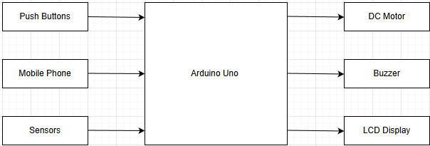

Fig. 1 Block diagram of the Washing Machine System.

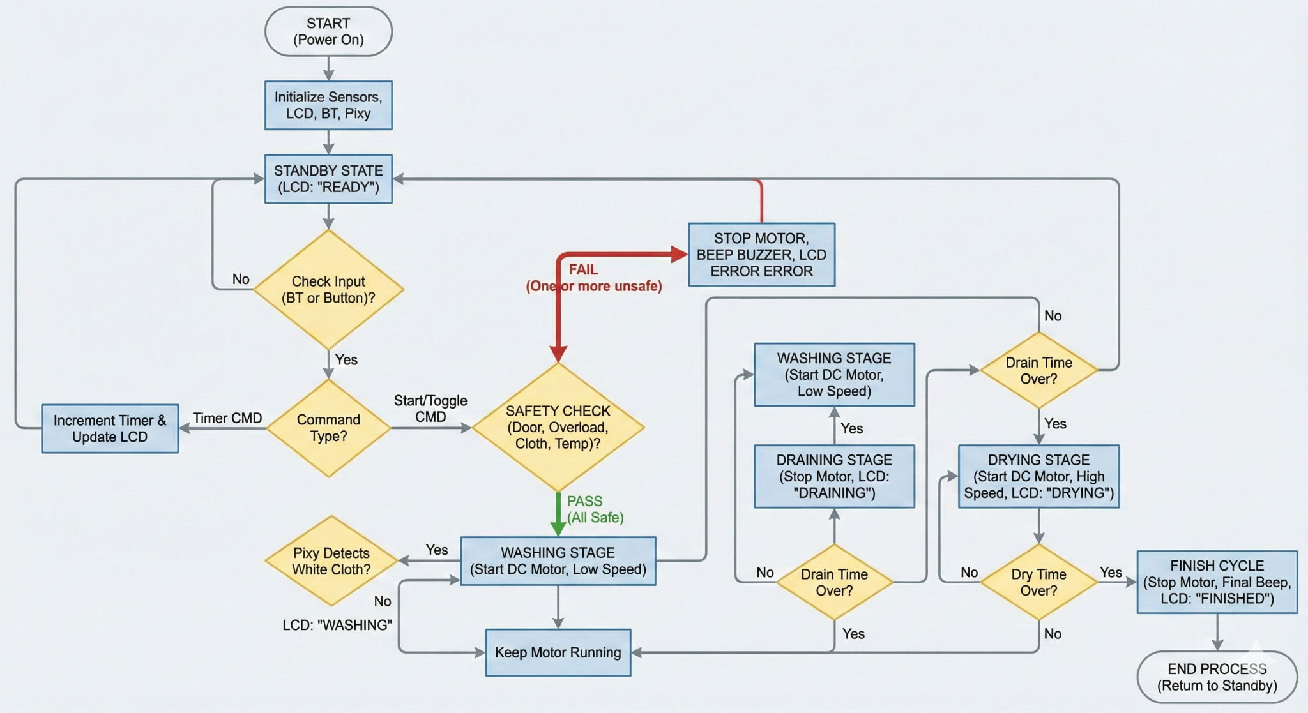
Fig. 2 The flow chart that explains all the work principles for the Washing Machine System.
2.2 Schematic Diagram and Prototype Setup
The schematic diagram (Figure 3) illustrates the complete electrical interface of the system, positioning the Arduino Uno as the central processing unit responsible for coordinating all peripheral components. Input devices, including an ultrasonic sensor, DHT11, IR sensor, limit switch, Pixy camera, and HC-05 Bluetooth module, are routed to specific digital and analog pins to transmit data to the controller. Upon processing these signals, the Arduino executes control commands, driving a DC motor via an L298N module for precise speed and direction regulation, while simultaneously triggering an LCD and buzzer to ensure effective visual and audible feedback.
The prototype setup consists of a transparent jar used as the washing drum, allowing visual observation of the washing process. The DC motor is mechanically coupled to the drum to simulate drum rotation. Sensors are mounted at suitable positions to ensure accurate detection, such as positioning the ultrasonic sensor above the drum and the IR sensor inside the drum. The limit switch is installed near the door mechanism to detect the door lock status. The complete prototype setup ensures a stable mechanical structure and reliable electrical connections.
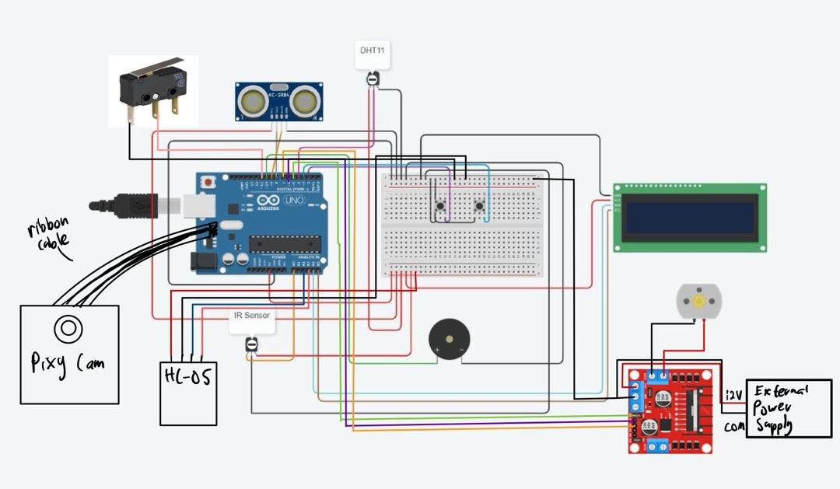

Fig. 3 Schematic diagram for the Washing Machine System.

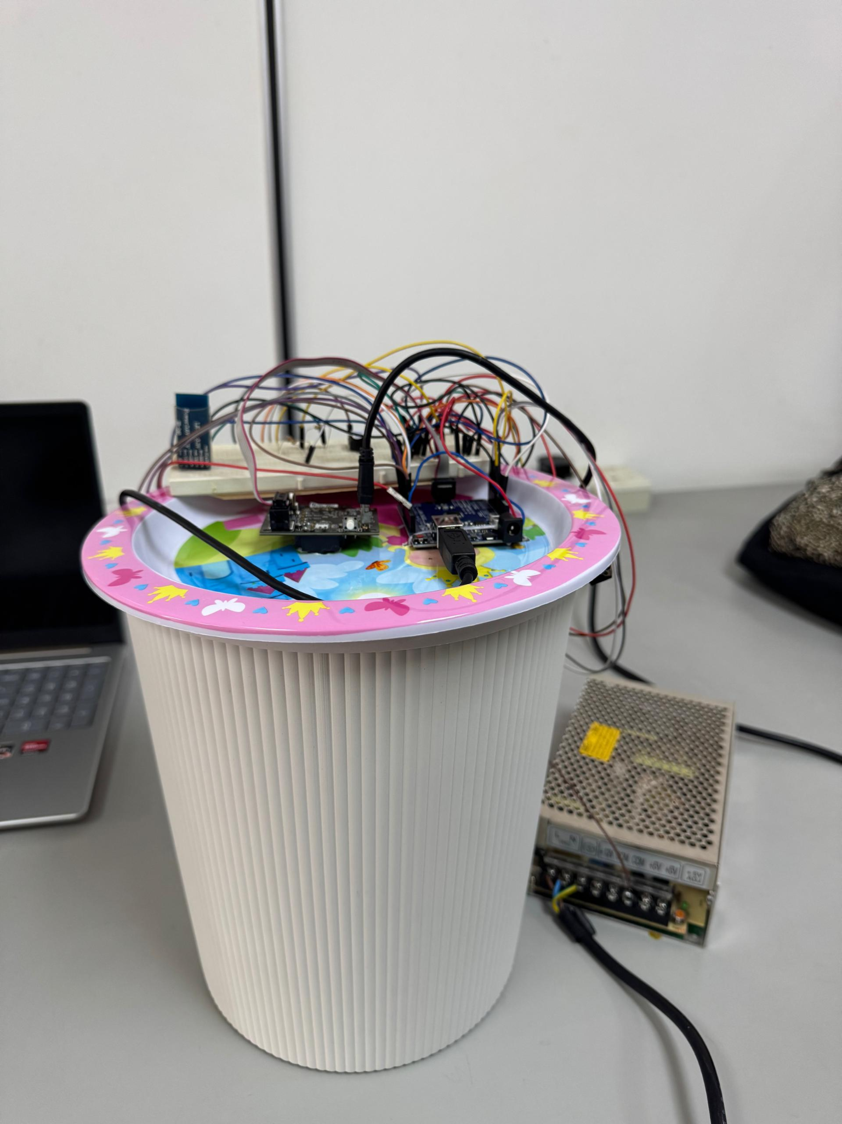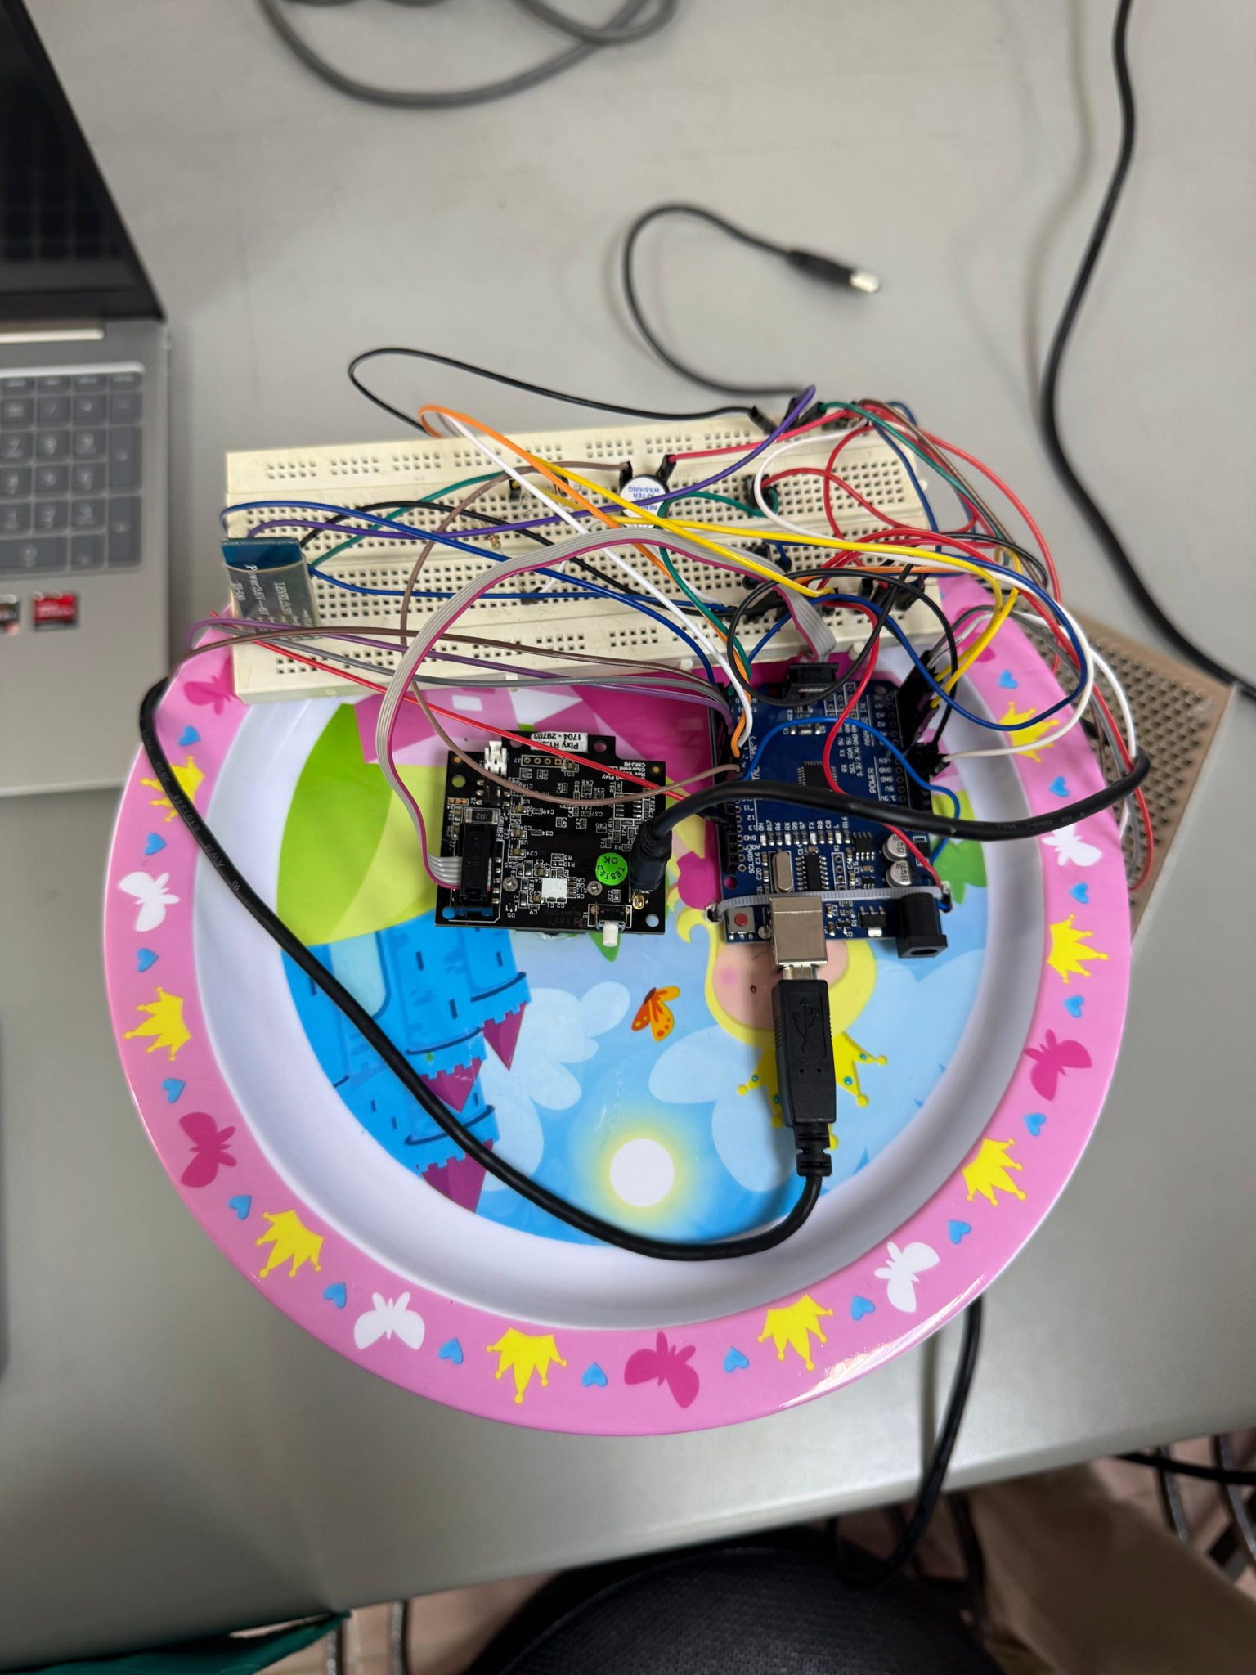
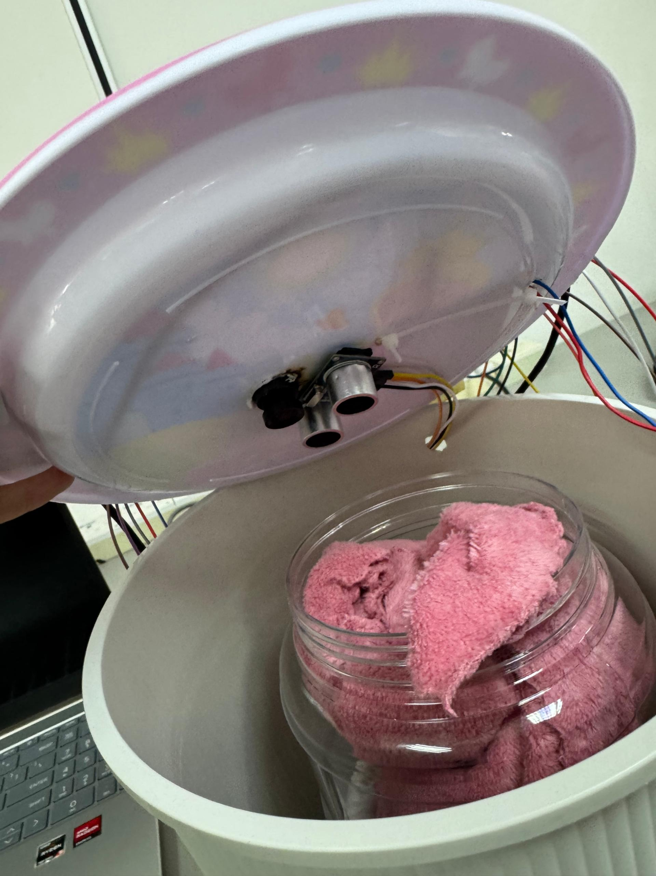
Fig.4 The Prototype setup using recycled items

3. RESULT AND DISCUSSION
3.1 Washing Cycle Operation and Stage Transition
The complete washing cycle was tested using all three selectable durations: 10 seconds, 20 seconds, and 30 seconds. During the washing stage, the DC motor rotated at normal speed. After the washing duration ended, the motor stopped for 5 seconds to represent the draining stage. Subsequently, the system entered the drying stage, where the motor rotated at a higher speed which is 255 RPM for 10 seconds.
The LCD accurately displayed the current stage (Washing, Draining, Drying) and the remaining time throughout the operation. Upon completion of the full cycle, the buzzer emitted five long beeps to notify the user. The smooth transition between stages indicates effective timing control and state management by the Arduino Uno.
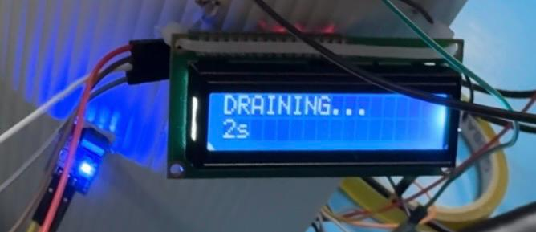
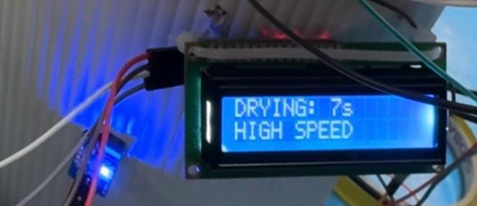
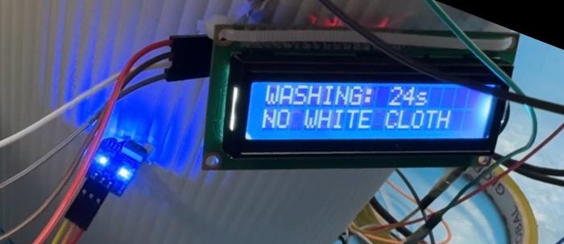
Washing mode Draining mode Drying mode

3.2 White Cloth Detection Using Pixy Camera
The Pixy camera was tested using different fabric colors placed inside the drum. Under adequate lighting conditions, the camera successfully detected white-colored fabric based on preconfigured color signatures. When white fabric was detected, the LCD displayed “WHITE CLOTH”. If no white fabric was present, the display showed “NO WHITE”.
The detection process was stable and consistent during testing. However, it was observed that lighting conditions affected detection accuracy, which is a known limitation of basic vision-based systems. Despite this, the Pixy camera effectively demonstrated the integration of machine vision into the washing machine prototype. This feature highlights the potential for future expansion into advanced fabric classification and intelligent washing programs.
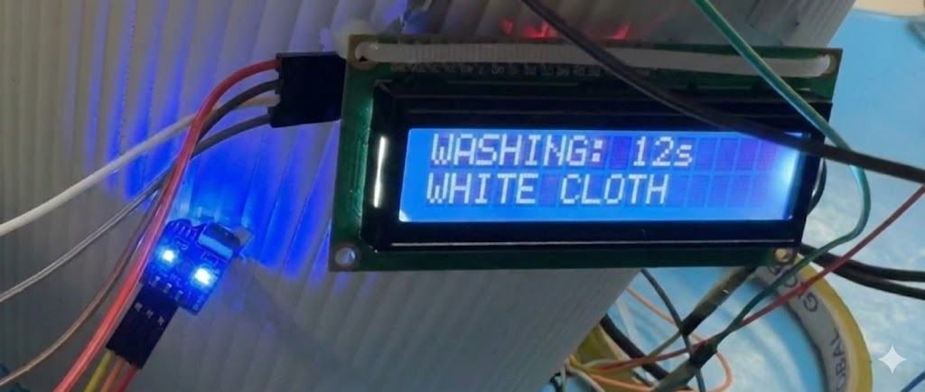

White cloth detected White cloth not detected
3.3 Door Lock Detection Using Limit Switch
The limit switch was tested by opening and closing the washing machine door during system operation. When the door was properly locked, the system allowed normal operation. When the door was unlocked, the system immediately prevented the washing cycle from starting or continuing.
In the unlocked condition, the buzzer emitted three short beeps, and the LCD displayed “DOOR OPENED!, STOPPING...”. The DC motor was disabled to ensure user safety. This safety mechanism performed reliably and consistently during repeated testing. The use of a limit switch provides a simple yet effective method for door lock detection in electromechanical systems.
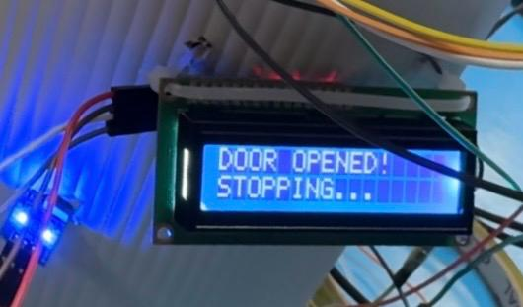
3.4 Laundry Presence Detection Using IR Sensor
The IR sensor was tested by operating the system with and without laundry inside the transparent drum. When laundry was present, the system proceeded normally. When the drum was empty, the IR sensor successfully detected the absence of laundry.
In the absence of laundry, the system prevented the washing cycle from starting. The LCD displayed the message “NO CLOTH, INSERT LAUNDRY”, and the buzzer emitted an alert sound. The DC motor remained stationary, preventing unnecessary energy consumption and mechanical wear. This feature effectively simulates real washing machine behavior and improves system intelligence by ensuring that the washing process only occurs when laundry is present.
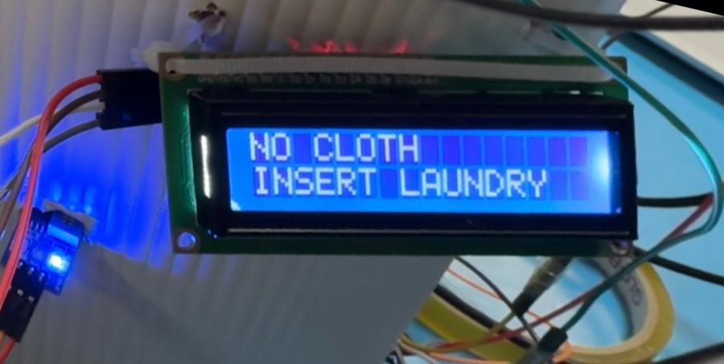
3.5 Overload Detection Using Ultrasonic Sensor
The ultrasonic sensor was tested by varying the amount of laundry placed inside the drum and measuring the distance between the sensor and the laundry surface. A threshold value of 5 cm was predefined as the overload condition. Experimental results show that when the measured distance was greater than 5 cm, the system allowed normal washing operation. However, when the distance was reduced to 5 cm or less, the system correctly identified an overload condition.
Upon detection of overload, the Arduino Uno immediately stopped the DC motor and activated the buzzer to alert the user. The LCD will display ‘OVERLOAD, REDUCE LOAD’ and the temperature value. This response occurred without noticeable delay, indicating efficient sensor reading and real-time processing. The overload detection system successfully prevented the motor from operating under excessive mechanical load, which could otherwise lead to overheating or motor damage. This result confirms that the ultrasonic sensor is suitable for basic load estimation in a prototype washing machine system.
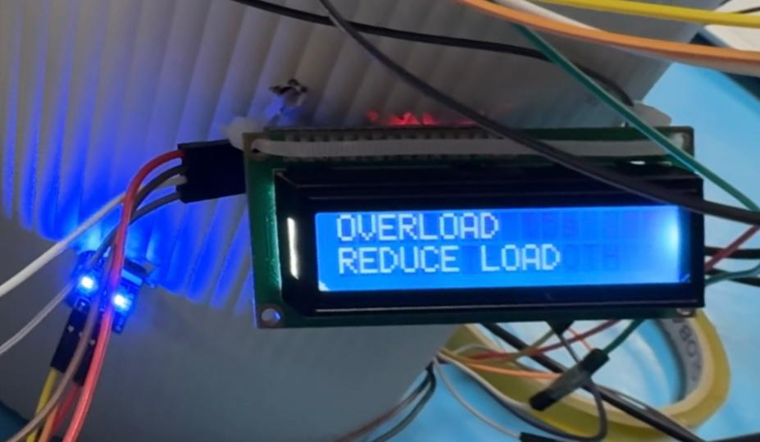
3.6 Temperature Monitoring and Overheat Protection
The DHT11 temperature sensor was evaluated by gradually increasing the ambient temperature around the system. When the temperature remained below 30°C, the washing machine operated normally. Once the temperature exceeded the predefined threshold of 30°C, the system identified an overheating condition.
During overheating, the Arduino Uno immediately stopped the DC motor and activated the buzzer continuously. The LCD simultaneously displayed a warning message ‘OVERHEAT’ to inform the user of the unsafe condition. The system remained in a halted state until the temperature dropped below the threshold. This behavior demonstrates effective thermal protection and shows that the system prioritizes safety over operation. The results confirm that the DHT11 sensor provides reliable temperature monitoring for low-cost embedded applications.
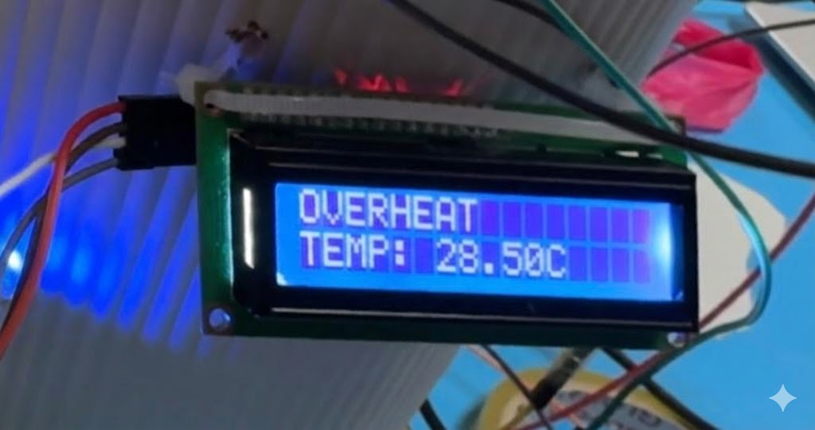
3.7 Bluetooth Control Performance (HC-05 Module)
The HC-05 Bluetooth module was tested by connecting the system to a smartphone using a mobile application which is Serial Bluetooth Terminal. Commands such as start, stop, and washing time selection were transmitted wirelessly to the Arduino Uno. The system responded accurately to all received commands with minimal communication delay.
The Bluetooth connection remained stable within a typical indoor range. The integration of wireless control improved user convenience and demonstrated the application of Internet-of-Things (IoT) concepts in smart appliances. This result confirms that the HC-05 module is suitable for basic wireless control in embedded systems.
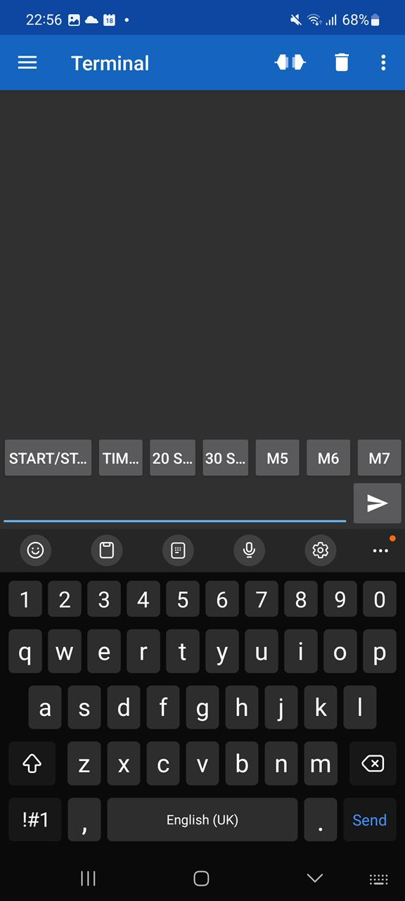
The interface in Serial Bluetooth Terminal app

4. CONCLUSION
To be conclude, the final conclusion is that this project has successfully designed and implemented a smart washing machine using an Arduino Uno board, combining various sensors, actuators, and communication modules. The designed system accurately identifies potentially harmful situations, namely overload, overheating, empty drum, unlocked door, and types of fabric, taking appropriate actions accordingly. This is achieved through motor control, displays on the LCD, and notifications. The system also uses a wireless control feature, conveyed by an HC-05 Bluetooth module, which can operate the washing machine with a smartphone.
The prototype builds on prior work in Arduino‑controlled washing machine systems by further enhancing safety and interaction features. The successful integration of sensing, control, actuation, and user interaction validates the Mechatronics System Integration approach adopted in this project. Future developments could explore more advanced fabric classification, automatic water management, and energy efficiency optimisation, further advancing the capabilities of embedded smart washing machines.

Acknowledgement
Sincere gratitude to the lecturer of the Mechatronics System Integration (MSI) course, Dr. Wahju Sediono, for the guidance, valuable advice, and continuous support provided throughout the completion of this project. The authors also wish to thank the laboratory technicians and staff for their assistance in providing the necessary equipment, components, and facilities required for the development and testing of the prototype.
In addition, we would like to acknowledge the support and cooperation of teammates who contributed ideas, suggestions, and encouragement during the project development process. Finally, special appreciation is extended to family members for their continuous motivation and support throughout the duration of this project.

Conflict of Interest
There is no conflict of interest regarding the publication of this project. The research and development of the smart washing machine prototype were conducted solely for academic purposes and were not influenced by any commercial, financial, or personal relationships.

Author Contribution
Author Name | Contribution
SITI NORATHIRAH BINTI RAZALLY | Responsible for the system design and project coordination. Developed the Arduino Uno control program, integrated all sensors and actuators, and performed system testing and debugging to ensure proper functionality.
ALI RIDHA BIN MUHAMMAD AMINUDIN | Focused on hardware implementation, including circuit wiring, integration of the L298N motor driver and DC motor, setup of the HC‑05 Bluetooth module, and assembly of the washing machine prototype.
NUR ALYA SAKINAH BINTI MOHD MOKHTAR | Responsible for system documentation, report writing, and analysis of experimental results. Also conducted experimental result analysis and data interpretation and helping with the purifying of the code.
All authors contributed to system testing, discussion of results, and final review and approval of the manuscript.
REFERENCES
[1] S. I. Shuaibu, 1. Abubakar, N. B. Kadandani, F. D. Sani and I. B. Olaleke,
"Experimental Implementation of Arduino-Controlled Solar Powered Washing Machine Prototype," Zaria Journal of Electrical Engineering Technology, vol. 12, no. 1-2, pp. 17-26, Sept. 2023.
[2] K. Pal, A. Majumdar, N. Banerjee, A. Ghosal, P. Daw, P. Pal, P. Dey and P.
Chakraborty, "Al-Based One Touch Input Washing Machine," IJRASET Journal for Research in Applied Science and Engineering Technology, Vol. 13, 2025.
[3] H. F. Masood, "Application of Fuzzy Logic in Design of Smart Washing Machine," arXiv preprint ar Xiv:1701.01654, Jan. 2017.
[4] "Design and Implementation of a Smart Hand Washing Machine Using Arduino," presented at 1st Multidisciplinary National Conference in Pharmaceutical Science and Technology (PHARMTECH), Kano State Polytechnic, Nigeria, Nov. 2021.
[5] Controlling led using HC-05 bluetooth module. (n.d.). Projecthub.arduino.cc. https://projecthub.arduino.cc/syedmahamood/controlling-led-using-hc-05-bluetooth-module-b7f411
[6] Söderby, K. (2021, November 18). Liquid Crystal Displays (LCD) with Arduino | Arduino Documentation. Docs.arduino.cc. https://docs.arduino.cc/learn/electronics/lcd-displays/
[7] wiki:v2:hooking_up_pixy_to_a_microcontroller_-28like_an_arduino-29 [Documentation]. (n.d.). Docs.pixycam.com. https://docs.pixycam.com/wiki/doku.php?id=wiki:v2:hooking_up_pixy_to_a_microcontroller_-28like_an_arduino-29
[8] Arduino - Limit Switch | Arduino Tutorial. (n.d.). Arduino Getting Started. https://arduinogetstarted.com/tutorials/arduino-limit-switch
[9] Fernando, L. (2024). Ultrasonic sensor with Arduino - Complete Guide. Arduino Project Hub. https://projecthub.arduino.cc/lucasfernando/ultrasonic-sensor-with-arduino-complete-guide-284faf
[10] Obstacle Detector using IR module - tutorial. (2021). Arduino Project Hub. https://projecthub.arduino.cc/aboda243/obstacle-detector-using-ir-module-tutorial-101320
[11] Using DHT11. (n.d.). Projecthub.arduino.cc. https://projecthub.arduino.cc/arcaegecengiz/using-dht11-12f621
[12] L298n Motor driver Arduino | Motors | Motor Driver | L298n. (2021, June 12). Projecthub.arduino.cc. https://projecthub.arduino.cc/lakshyajhalani56/l298n-motor-driver-arduino-motors-motor-driver-l298n-7e1b3b

